**Manufacturing completed for full-scale prototypes of ITER first wall panels**

[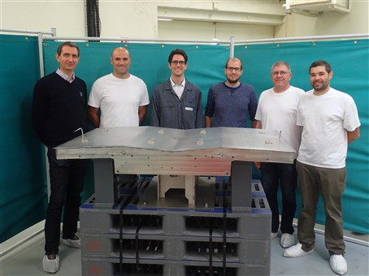](https://f4e.europa.eu/Downloads/News/P9130717-011020191200-Large.jpg)

Members of the Atmostat team involved in the manufacturing of a full-scale prototype of the ITER first wall panel, financed by F4E.

The hot gas inside the ITER machine will reach temperatures ten times higher those in the core of the Sun. A burning plasma of 150 million °C will be ignited and with the help of powerful superconducting magnets it will be confined without touching the surface of the vacuum vessel. The chamber housing the fusion reaction will be protected with a layer of 440 first wall panels. Over 600 m2 will be covered from top to bottom with thick metallic blocs, which resemble to thick metallic shiny tiles. Each of the first wall panels measures 1 x 1.5 m and weighs up to 1.5 T. Shield blocks will be installed in the rear of each panel to form the ITER Blanket.

Europe will manufacture 215 of the first wall panels-roughly half of the total. The rest will be delivered by China and Russia. Given the fact that it’s a first for industry to fabricate this piece of equipment, much effort has been put in developing conceptual designs, starting off with smaller mock-ups leading to real-size prototypes. F4E has been working with: i) [Framatome](http://www.framatome.com/EN/home-57/index.html) ii) [Atmostat](https://www.atmostat-alcen.com/en); and iii) a consortium consisting of [Iberdrola](https://www.iberdrola.es/), [Wood](https://www.woodplc.com/) and [Leading](https://www.leading.es/acercade_eng.html) for the phase of prototypes. There is good news for all because manufacturing has been completed. Factory acceptance tests have been completed for two of the three prototypes with the final one on-going.

“Reaching this technical milestone required patience and persistence, given the fact that we all in a learning curve,” explains Stefano Banetta, managing on behalf of F4E the progress of this component. “Due to the fact that we scaled up our prototypes, there was a direct impact on the manufacturing process. We all learned a lot and took a significant step together when we entered the phase of production. Next, we will perform a series of strict quality tests to check the performance of the equipment in high temperatures,” he explains.

The companies involved in their production are of the same opinion. They acknowledge that it has not been easy but they are proud of having made it so far. The management team of the consortium comprising Iberdrola, Leading and Wood, stated that “technical experience in bonding, treating and machining of exotic materials have been deployed to deliver a cutting-edge prototype which is an important step in order to produce a full series of first wall panels in future.”

ITER first wall panel full scale prototype manufactured by Iberdrola, Leading and Wood, financed by F4E.

Erwan Bouvier, Atmostat, ITER Project Manager, confirms that “producing the full scale prototype has been both an industrial and a technical challenge. It successfully concludes a long-running partnership with F4E on a wide set of innovative manufacturing processes.”

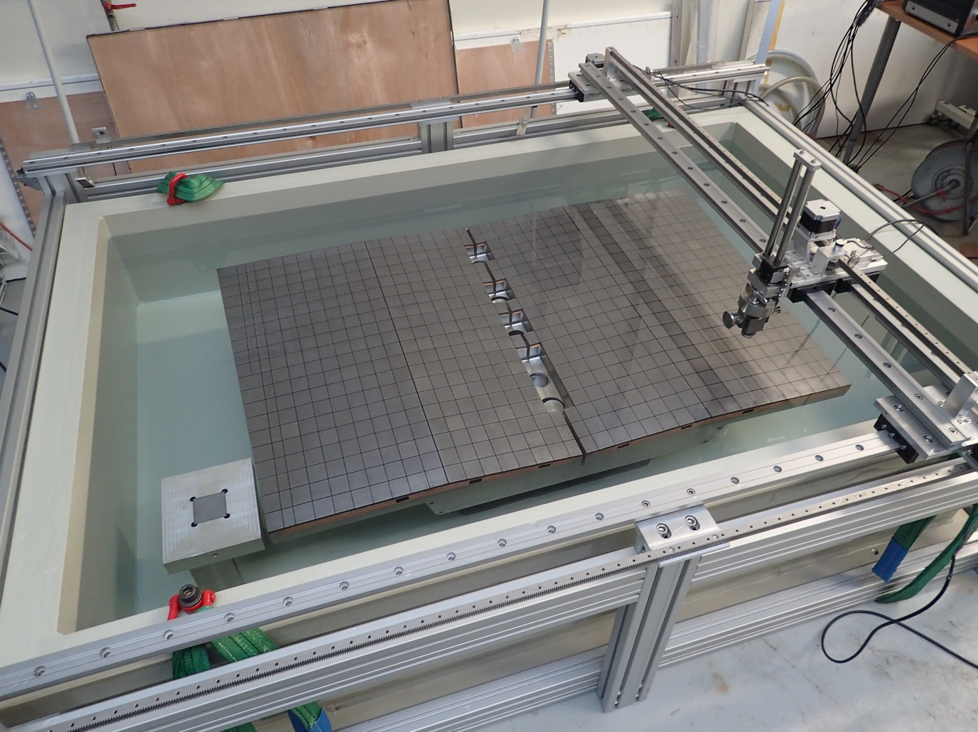

ITER first wall panel full-scale prototype manufactured by Atmostat, undergoing an ultrasonic test in a bathtub. The works have been financed by F4E.

On behalf of Framatome, Delphine Bossu, explains that “the success of this full-scale prototype represents 20 years of development in competencies required to produce such a challenging component. Through this contract, Framatome has successfully industrialised different processes and is prepared for the manufacturing of the first wall panel series.”

ITER first wall panel full-scale prototype manufcatured by Framatome, financed by F4E.

“Better insight and more know-how have been acquired after years of work in this area. The successful manufacturing of the three full-scale prototypes have paved the way for the launch of the F4E call for the production of the first-wall panels,” explains Patrick Lorenzetto, F4E Project Manager for In-Vessel.